Handheld Isotope Identification Instrument RIID

RT-30 Mk II series

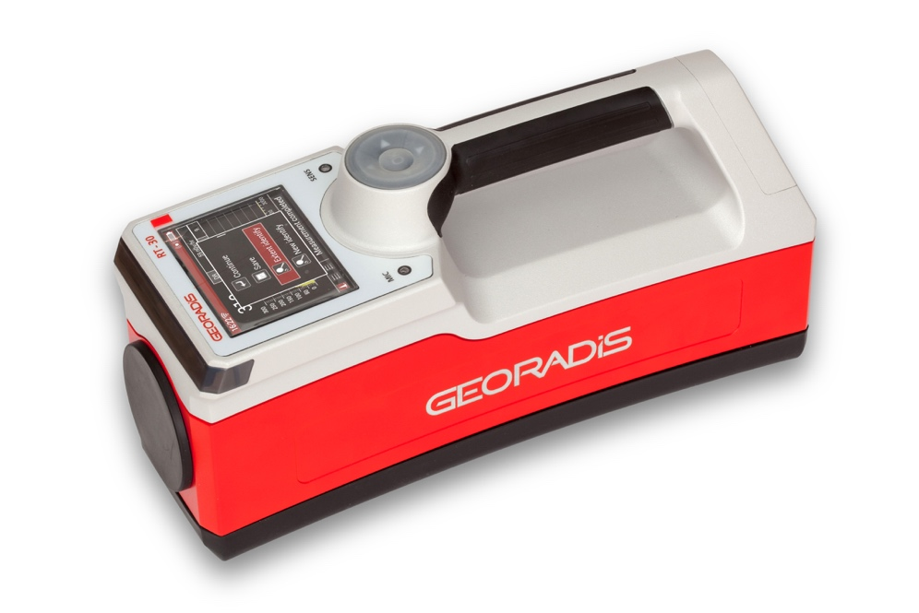
The RT-30 Mk II is second generation of popular handheld gamma ray spectrometer RT-30. Strengths of the first generation were copied in the new model. There has to be highlighted a strong alloy body sealed against dust and water, protective removable rubber boot, comfortable grip and low weight. The Mk II learned of the weaknesses of the first generation and features a large colored transreflexible sun readable display, improved user’s interface with five operation buttons, removable but well-sealed battery pack and clear and loud audio.

The instrument is built as an open platform with potential of fast and simple implementation of special features required by customers. Wide fleet of detectors is supported. The Mk II bridges traditional scintillation detection probes using common vacuum photomultiplier tube with up-to-date silicone photomultipliers technology. Saved significant volume of vacuum tubes is next occupied by larger size of detector.
- Excellent Sensitivity – highest ratio detector to unit volume
- Fast and Reliable Isotope Identification
- Lightweight, Rugged and Compact design
- Easy Operation
- Automatic Stabilisation on Natural background
- USB C and wireless connections
- Weather protected
- 2-Year Warranty

A heart of gamma ray spectrometer is FPGA (programmable array) plus fast speed and low consumption ARM type processor. The concept is taken of preceding larger instrument and has been tested for years. Beside gamma ray section the FPGA is capable to handle other sensors at the same time. A Geiger-Mueller counter and a Neutron detector make a standard offer.

Thanks to latest electronic the Mk II opens a platform for supporting most modern existing communication standards. Sharing new and traditional communication standards is guaranteed wide compatibility with older as well as new communication devices. The existing USB was upgraded to level C and beside communication it is used also for unit’s battery charging. GPS system is built in front part of the instrument. Information of it is used for localization of the unit and also for time synchronization.
Applications
- Homeland Security and surveillance operations
- Customs and Border protection
- Hospitals and Health physics
- Nuclear facilities
- Waste Recycling and Incineration plants
- Scrap metal recycling
- Research laboratories
- Production facilities

Quickly determining the location of lost radioactive sources in the environment or scrap, monitoring of waste in hospitals or waste incinerators, scanning people or baggage to disclose illicit trafficking of nuclear materials; all are typical applications for the RT-30 Mk II series.

Features:
- Ergonomic, lightweight handheld well balanced, compact
- Comfortable grip with five buttons operable in glows
- Removable protective rubber boot
- Detectors fully build in the housing, protected by rubber foam
- Large, transreflexible colored display - sharp and high contrast at sunlight, backlighted in dark
- Loudspeaker with plastic membrane watertight

- Four status indication LEDs – indication of alarms and health status
- USB standard C for data transfer and charging

- Wide fleet of scintillation detectors NaI/Tl, CsI/Tl, CsI/Eu, LaHalide, BGO, GAGG, SrI, Plastic scintillation detectors PVT.
- Maximum detector size: Diameter 2” and height 2” with standard vacuum PMT or max 5” with Silicone PMT (SiPM or MPPC)

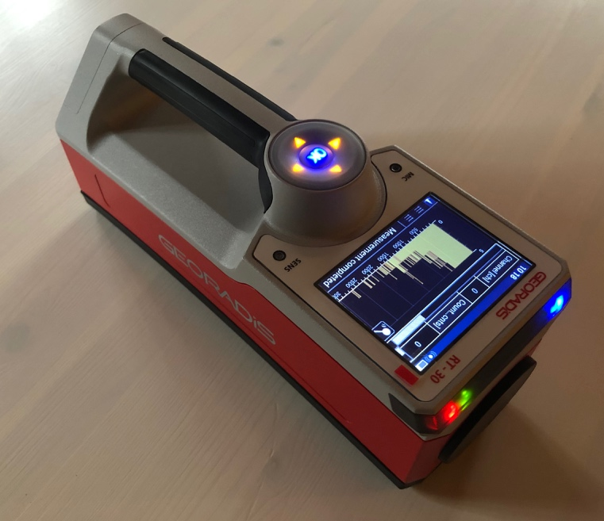
Gamma Ray spectrometer with full digital signal evaluation
- Fast sampling - 40 Mega sample/sec
- Pulse shape auto calibration - easy adaptation to different type of detectors
- Standard energy range 20 keV - 3 MeV in 1024 channels. Linear transition between energy and channel position. Linearization made on one million of microchannels using a lookup table.
- Energy range extendable up 10 MeV
- Progressive gain adjustment using NORM pattern with range overlap. Gain adjustment performed by a proportional backstage process regardless of working mode.
- Detailed and complex gain stabilization log for arbitrary reasons and long-term performance check.

Search Mode – Survey Meter
- Used for a source of radiation localization. Indication of intensity by gamma rate total counts or counts within predefined energy windows, dose rate, accumulated dose and neutron flux.
- Survey Meter
- Dose Rate Meter
- 1024 Ch Spectrometer
- Highly Sophisticated Algorithms
- Automatic Stabilisation on Natural background
- Scanned profile recorded on histogram. Anomalies highlighted by colors. Browsing capability of recorder within one recording session.
- Waterfall screen mode for indication of intensities within spectrum.
- Adjustable alarm thresholds for gamma rate, dose and dose rate.
- Neutron warning active within all modes since unit is on.
- Measured values integration and averaging mode - running average.
- Loud acoustic indication of level of radiation.
- Thresholds for acoustic indication and highlighting colors of recorder auto adjustable from actual background.

Nuclide Identification Mode
- Sensitive Gaussian filtering, doublet recovery algorithm
- Default and user customable nuclide libraries, improved identification rules
- Found peaks listed with details about resolution, intensity and position
- Contribution power of Identified nuclides in blends rated by intensities
- Nuclide categories by their origin (Industrial, NORM, Medical, SNM)
- No limit on number of items in nuclide library

NORM Assay Mode

- Evaluation of concentrations of NORMs by least square fitting.
- Two calibrations - default and user editable
- Results in form value and determined standard deviation.
- Capable to determine up 6 nuclides in a blend.
- Information about quality of a measured spectrum.
- Spectrum drift correction

Special Mode
- Extended Energy Range Mode
- Energy range of gamma spectrum expandable up 10 MeV
- Pulse time capturing system
- Variable look up tables

Detector options:
- SiPM scintillation detector with silicone photo multiplier
- L1, L2, L3, L4, L5 customized height of detector (1, 2, 3, 4 and 5 “). L3 and L5 only with SiPM
- T telescopic extension for gamma and GM detector
- NaI, CsI and BGO as common, other types as GAGG, YAP, SrI, LaH, PVT customized

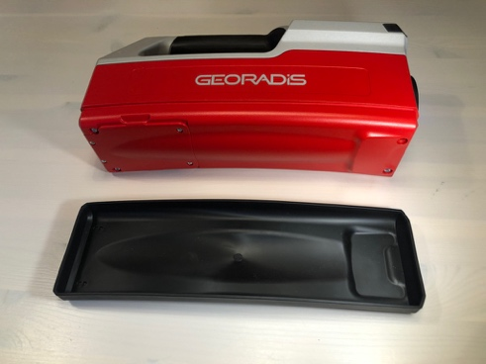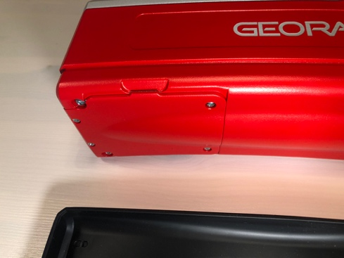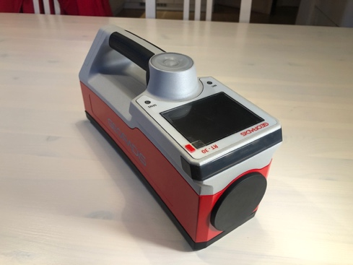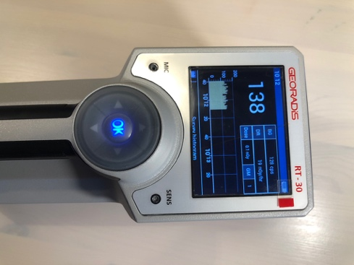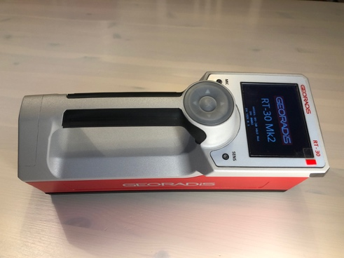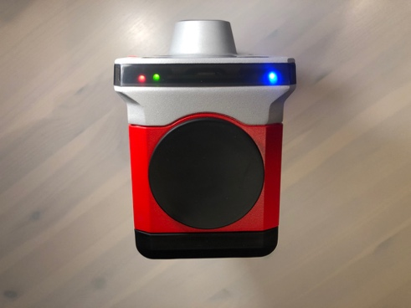

RT-30 Mk II Product Range
The RT-30 Mk II series has an IP65 dust- and water resistant, lightweight alloy milled housing and a detachable plastic boot with for additional protection under harsh environments. The unit is powered by a removable Li-ION battery pack. A fully automatic charger is integrated in the unit. One plug in connector USB-C for data transfer and charging.

Standard Comparison Table |  | RT-30MkII | RT-30MkII T | RT-30MkII G | RT-30MkII GT | RT-30MkII N | GT-30MkII | GT-32MkII | RT-30MkII SiPM | RT-30MkII T SiPM | RT-30MkII N SiPM | GT-30MkII SiPM
Display | Numerical
Display | Graphical | ● | ● | ● | ● | ● | ● | ● | ● | ● | ● | ●
Data acquisition | Gross Counting | ● | ● | ● | ● | ● | ● | ● | ● | ● | ● | ●
Data acquisition | Spectroscopy | ● | ● | ● | ● | ● | ● | ● | ● | ● | ● | ●
Connectivity | USB C | ● | ● | ● | ● | ● | ● | ● | ● | ● | ● | ●
Connectivity | Bluetooth and Wi-Fi | ● | ● | ● | ● | ● | ● | ● | ● | ● | ● | ●
Memory
Memory | Large (32Gb) | ● | ● | ● | ● | ● | ● | ● | ● | ● | ● | ●
Software | GeoView Package | ● | ● | ● | ● | ● | ● | ● | ● | ● | ● | ●
Software | Isotope Identification | ● | ● | ● | ● | ● |  |  | ● | ● | ●
Software | Assay mode |  |  |  |  |  | ● | ● |  |  |  | ●
Detector type | NaI, 30 x 30mm
Detector type | NaI, 51 x 51mm | ● | ● | ● | ● | ● | ●
Detector type | NaI, 51 x max 120 mm |  |  |  |  |  |  |  | ● | ● | ● | ●
Detector type | BGO, 51 x 51mm |  |  |  |  |  |  | ●
Detector type | Alternative det. type |  |  |  |  |  |  |  | ● | ● | ●
Detector type | GM tube |  |  | ● | ● | ● |  |  |  |  | ●
Detector type | Neutron Detector |  |  |  |  | ● |  |  |  |  | ●
Mechanical | Handheld | ● |  | ● |  | ● | ● | ● | ● |  | ● | ●
Mechanical | Telescopic arm |  | ● |  | ● |  |  |  |  | ●

Common Features
- Large scintillator, selectable type
- Advanced GUI operation
- Automatic Stabilisation on Natural background
- Selectable acoustic and visual alarm threshold, LED indication
- Sophisticated Nuclide Identification procedures
- Bluetooth and Wi-Fi communication, Ethernet connectivity
- Build in GPS, Glonass
- 32Gb internal memory
- Lightweight, robust design
- Optional Telescopic arm, Integrated GM tube or Neutron Detector
- LCD Graphic colour display transreflective
- Removable protecting boot
- Replaceable battery pack



Technical data
Detectors

Standard option
NaI/(Tl), Φ51 x 51 mm (2“ x 2“), 104 cm3 (6.3 in3), all RT models
BGO), Φ51 x 51 mm (2“ x 2“), 104 cm3 (6.3 in3), GT-32 Mk II model
Photomultiplier diameter 2”, bialkali
Energy compensated GM tube with RT-30 Mk II G, RT-30 Mk II GT and RT-30 Mk II N
He-3 Neutron tube with RT-30 Mk II N

Special option

CsI/(Tl), CsI/Eu, LaH, SrI, GAGG, YAP , Φ51 x max 120 mm (2“ x max 5“), SiPM array

Spectrometer

1024 channel, 40 MHz DSP, Linear Energy corrected
Pile-up Rejector, 200 ns Resolution
Energy range 20keV - 3,0 MeV, expandable up 10 MeV

Scintilometer
Sampling period 20/second
Acoustic and video alarm, 4 LED indicators
Moving average and integration

Dose Meter
Energy corrected dose rate for NaI detector, H*10
Extended range with GM tube 100 mSv/h (10 R/hr)

Gamma ray sensitivity at 1m (NaI/Tl 2x2”)
160 cps/1MBq for Cs-137
75 cps/1MBq for Am-241
270 cps/1MBq for Co-60

Display
Colour LCD, 360 x 240 dots, 72 x 54 mm (3.5”), Sun readable
Automatic Backlight

Acoustic indication
audio frequency is proportional to measured count rate
Speaker, dia. 28 mm + Built-in Microphone

Control
Illuminated Navigation Joystick, 5 positions

Data Storage and Transfer
32 GB memory for spectra, search profiles and dose, min. 8000 Samples with full Spectra, Data Position and Voice Message
USB-C, direct and Ethernet mode, Bluetooth 1.2 Class 2 and Wi-Fi

GPS Support
Internal - GNSS engine for GPS/QZSS, GLONASS, 56-channels
NMEA 0183
External GPS connectable

Power
Rechargeable Li-ion 7.2 V / 6600 mAh (Panasonic CGR18650CG/2S3P) – min. 8 hours of operation at 20ºC
External AC adapter USB-C 60W for charging or measurement

Environmental
IP-65 Dust and Water resistant
Operating temperature range -10°C to +50°C
RFI/EMF Shielding complies with FCC(47 CFR part 15) for
Class A CE Certification

Size and weight
Size L x W x H 29 cm x 10 cm x 16 cm
Weight 3 kg

Standard accessories:

Carrying Durable Suitcase
Battery charger
GeoView Software
USB cable
User’s guide
Calibration protocols

Optional accessories:

Shoulder Carrying Harness
Spare Battery Pack

Specifications are subject to change without notice

Production and service: GEORADIS s.r.o. Distribution:
Novomoravanská 321/41
619 00 Brno, CZ
Phone: +420 541 422 236
Fax: +420 541 422 232
E-mail: info@georadis.com
V1.00-2021-01-RT30 MkII Web: www.georadis.com

